
a
Company
Logotype

Cone Beam Computed Tomography- Report



Porur Dental X-rays & CBCT

Patient Name : Dr. Sangeetha | Date of Report : 30.06.2024
Age/ Gender : 43 years/ Female | Region of Interest : CBCT Maxilla
Referring doctor: Dr. T. S. Meenakshi | Indication : Implant assessment
Clinical Notes: Nil
PATIENT INFORMATION

CBCT- Maxilla provided
CBCT – IMAGE DETAILS

RADIOGRAPHIC INTERPRETATION

- Completely missing crown and root portion in relation to 16, 18, 26.
- Root stumps: 27.
- The maxillary alveolar ridge is present with normal trabecular pattern.

IMPLANT ASSESSMENT

 | 16 region | 17 region | 26 region | 27 region | 28 region
Sub-Crestal (in mm) | - | 13.2 | - | - | 11.65
Mid- Crestal (in mm) | - | 12.82 | - | - | 11.97
Distance between the alveolar ridge and floor of the maxillary sinus (in mm) | 2.11 | 8.13 | 0.65 | 2.16 | 6.63

RADIOGRAPHIC IMPRESSION

- Partially edentulous maxillary arch.
- Root stumps: 27.

Kindly correlate with clinical findings


IMAGES FOR REFERENCE

RECONSTRUCTED PANORAMIC VIEW
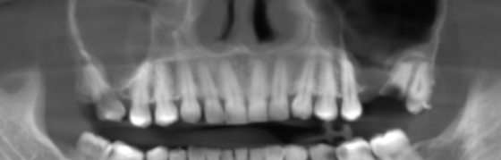

3-DIMENSIONAL VIEW

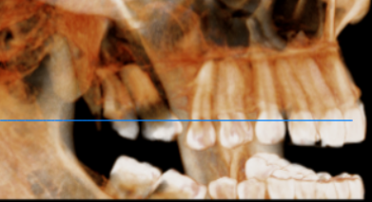

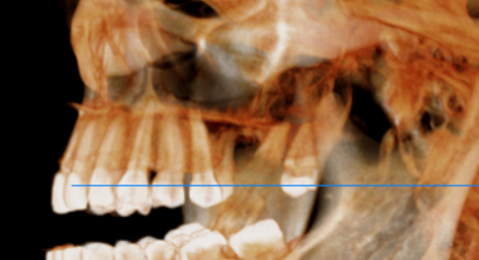

CROSS SECTIONAL VIEW

16 region | 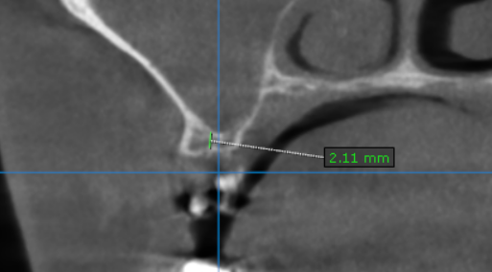
17 region | 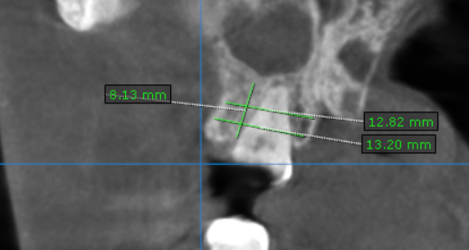
26 region | 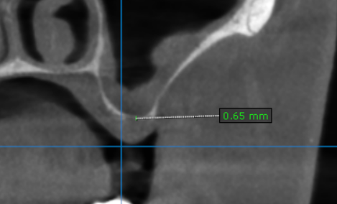
27 region | 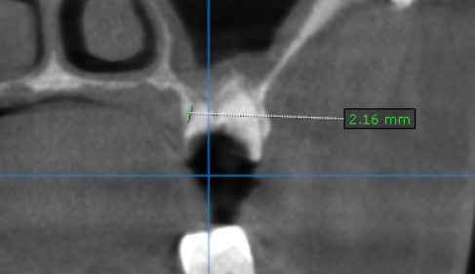
28 region | 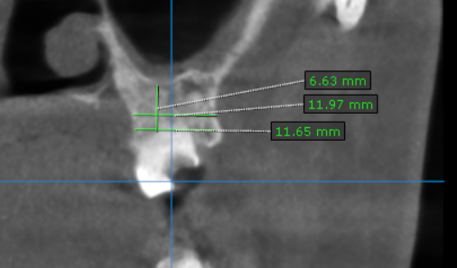

**** End of report ****

